Buoyancy & Bulkheads Experiment

# Different Hole Sizes

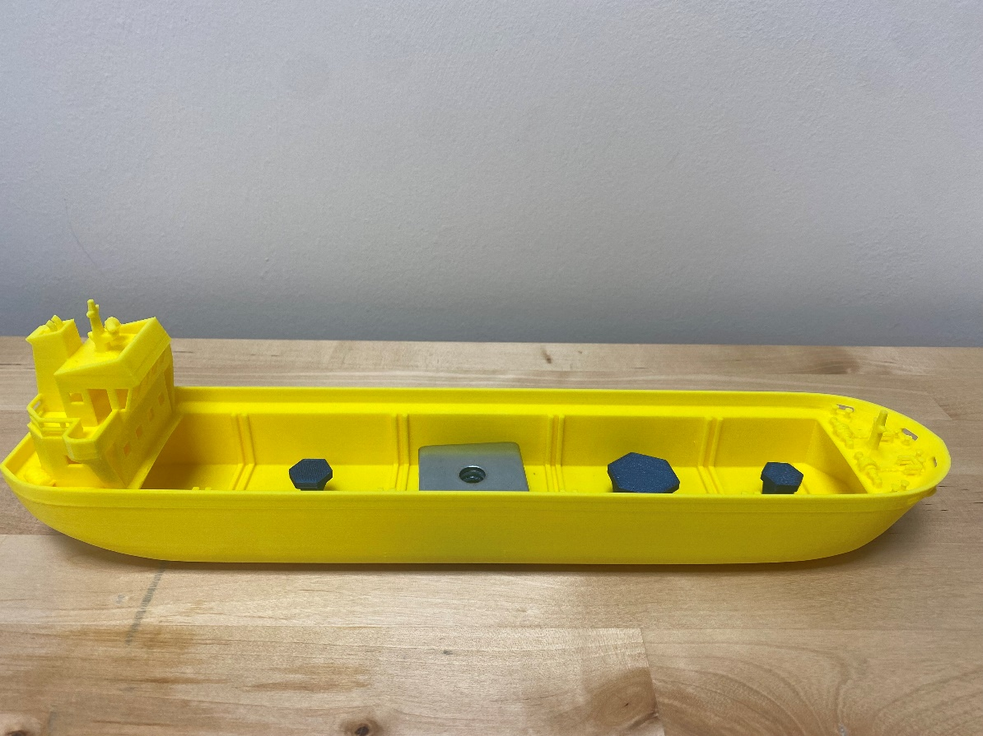

Zone C

Zone C

Zone D

Zone E

Zone B

Zone A

Use 6 weights in Zone C of the ship. Measure how long it takes the ship to sink with each size of hole. Start your timer when the ship touches the water. End your timer when the ship touches the bottom of the tub.

|  |  |  |  |
| --- | --- | --- | --- |
|  | Small Hole | Medium hole | Large Hole |
| Predicted Time |  |  |  |
| Actual Time |  |  |  |

# Different Weights

Use only the **Small Hole** for this experiment. Measure how long it takes the ship to sink with different amounts of weight. Start your timer when the ship touches the water. End your timer when the ship touches the bottom of the tub.

|  |  |  |  |  |
| --- | --- | --- | --- | --- |
|  | 6 Weights | 8 Weights | 10 Weights | 14 Weights |
| Predicted Time |  |  |  |  |
| Actual Time |  |  |  |  |

# Bulkheads

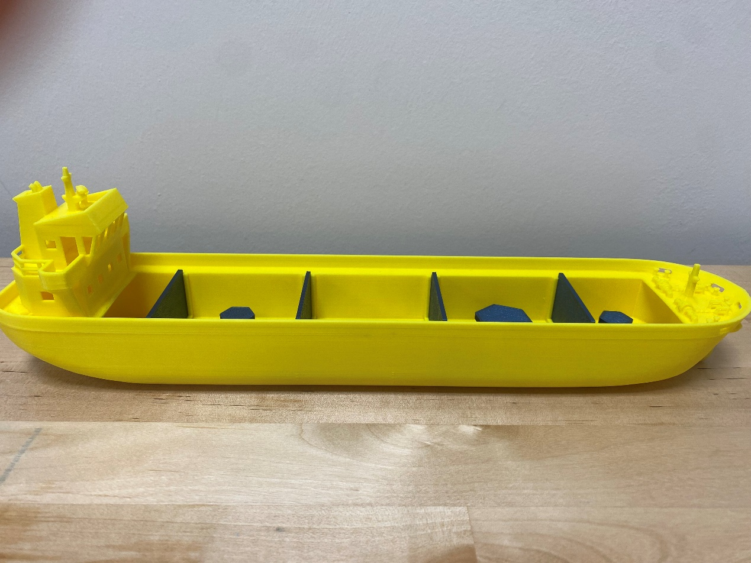

Bulkhead 2

Bulkhead 1

Bulkhead 3

Bulkhead 4

Now we will investigate how using bulkheads impacts sinking time. Use 9 weights in Zone C and the large hole. Measure the time taken for the ship to sink with all the bulkhead combinations in the table below.

|  |  |  |  |  |
| --- | --- | --- | --- | --- |
|  | Bulkhead 4 | Bulkhead 3 | Bulkheads 1 & 2 | Bulkheads 1, 3 & 4 |
| Predicted Time |  |  |  |  |
| Actual Time |  |  |  |  |

# Half Bulkheads

Repeat experiment 3 using bulkheads that are half as tall.

|  |  |  |  |  |
| --- | --- | --- | --- | --- |
|  | Bulkhead 4 | Bulkhead 3 | Bulkheads 1 & 2 | Bulkheads 1, 3 & 4 |
| Predicted Time |  |  |  |  |
| Actual Time |  |  |  |  |

# Your Turn

It is your turn to be naval architects. Use 2 full bulkheads and 1 half bulkhead to design your own ship to survive against a hole. There will be 8 weights in Zone C and you can choose which hole to use.

|  |  |  |  |  |
| --- | --- | --- | --- | --- |
|  | Hole | Bulkhead | Bulkhead | Half Bulkhead |
| Your Design |  |  |  |  |

|  |  |  |  |
| --- | --- | --- | --- |
| Predicted Time |  | Actual Time |  |